
Email:milleniumstar.enterprise@ymail.com Telefax:(049)5081582

QUOTATION
To:Pricon MSE080520
Attn:Ms.Rebecca Valenzuela August 5,2020
CC: Mr.Arnold Martinez/Mr.Aljhon Anonuevo
Subject:inquiry
Ma’am
We are pleased to quote you as follows. We highly appreciated your interest in our company.
And we are looking forward in seeing your purchase order.Thank you very much for your inquiry.
ITEM QTY. DESCRIPTION Unit Price Total Amount
1 1pc Barrel heater Usd225.00/pc Usd225.00
Inside Diameter mm : 60
Width mm: 40
210v 1000w
Brass material
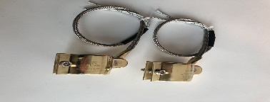
2 1pc nozzle heater Usd210.00/pc Usd210.00
Inside Diameter mm : 45
Width mm: 40
210v 250w
Brass material

Delivery:2weeks
Price :DDU
Terms:End of next month after the month end closing

If you have any queries please don’t hesitate to contact us.
Sincerely ,
Johnna Villaceran

